**ASHESI UNIVERSITY COLLEGE**

**CENTRALIZED HOSPITAL AND PHARMACY MANAGEMENT**

**SYSTEM**

**FREDRICK OHENEBA ABAYIE**

**2016**

**APPLIED PROJECT**

**ASHESI UNIVERSITY COLLEGE**

**CENTRALIZED HOSPITAL AND PHARMACY MANAGEMENT**

**SYSTEM**

By

**FREDRICK OHENEBA ABAYIE**

Dissertation submitted to the Department of Computer Science,

Ashesi University College

In partial fulfillment of the requirements for the award of

Bachelor of Science degree in Computer Science

**APRIL, 2016**

**Declaration**

I hereby declare that this dissertation is the result of my own original work and that no part of it has been presented for another degree in this University or elsewhere.

Candidate’s Signature: ………………………………………………………………..

Candidate’s Name: ……………………………………………………………

Date: ……..…./……………./………….

I hereby declare that the preparation and presentation of the dissertation were supervised in accordance with the guidelines on supervision of dissertation laid down by Ashesi University College.

Supervisor’s Signature: ………………………………………………………………..

Supervisor’s Name: ……………………………………………………………

Date: ……..…./……………./………….

**Acknowledgements**

I would like to express my sincerest gratitude to my project supervisor Mr. Aelaf Dafla, for his guidance and support throughout this project.

**Abstract**

Table of Contents

Chapter 1: Introduction 7

1.1 Introduction and Background 7

1.2 Problem Statement 8

1.3 Motivation 8

1.4 Objectives 9

1.5 Research 10

Chapter 2: Requirement Engineering 11

2.1 Functional Requirement 11

2.1.1 System Administrator 11

2.1.2 Doctors 12

2.1.3 Nurses 13

2.1.4 Pharmacist 13

2.1.5 Laboratory Technicians 14

2.2 Non-Functional Requirement 14

2.2.1 Product Requirement 14

2.2.2 Organizational Requirement 15

2.2.3 External Requirement 15

2.3 Requirement Elicitation and Analysis 15

2.3.1 Scenarios 15

2.3.2 Use Cases 16

Chapter 3: Architecture And Design 18

3.1 System Architecture 19

3.2 Architectural Pattern 20

Chapter 4: Implementation 22

4.1 Process Model 22

4.2 Tools and Technology 22

4.3 Platform 24

4.3.1 Web Version 24

4.3.2 Mobile Version 24

4.4 Web Interface 25

Chapter 5: Testing and Results 27

Chapter 6: Conclusion 28

Chapter 7: Conclusion and Recommendation 29

Bibliography 31

# Chapter 1: Introduction

## 1.1 Introduction and Background

This project is aimed at developing a software for hospitals and pharmacies in Ghana to help minimize self-medication and also to assist health personnel in keeping accurate records of patients. Most hospitals in Ghana do not have proper record keeping systems in place to record patient’s details (including name, age, disease, prescriptions etc.) and manage them properly (Nyonmorworko, 2015). Also, patients do not get a formal report after visiting hospitals. This software will not only allow health personnel to enter details of patients but also the hospital management will be able to use the software to generate statistical reports and also to process health insurance claims. The software will allow pharmacies know more information about the patient drugs are being given. Examples of such information will be the name of the patient, age, the hospital he/she visited and the patient’s doctor.

## 1.2 Problem Statement

Currently, most of the health services in Ghana do not have better record keeping of their patients. These hospitals store patient information of pieces of paper and stored in folders which is also made of paper. In a scenario where there is a fire outbreak or flooding in the hospitals, all the necessary documents of patients could be lost. This is a crucial problem because if the health of a patient is not tracked properly it could lead to more complications or even the patient losing his/her life. Also the time it takes for a OPD staff to search for the folder of a particular patient has an impact on quality of health services delivered when the patient has misplaced his/her card. Furthermore, the processing of insurance health claims is slower when the health personnel submit the claims in a paper format. The software will help in transitioning from paper passed record keeping to electronic record keeping, generate statistical reports and help health personnel to send health insurance claims.

## 1.3 Motivation

The urgent concern discovered in most hospitals is the time that patients wait for their files to be found before they get to see a doctor. It takes longer in cases where the patient has lost his hospital card or does not remember the last time he visited that hospital. This could be a difficult job for the nurses whom are to search for a particular file amongst thousands of other files. In certain cases, the file of a patient could not be found or if found could be badly damaged. The time it takes a nurse to search for a particular patient’s file could be reduced drastically when proper record keeping systems are put in place.

Normally when a patient goes to a hospital, after waiting minutes or even hours for his files to be found, the doctors write drug prescriptions on a piece of paper for patients to buy them from a pharmacy. There could be a scenario where the pharmacist mistakenly gives a patient the wrong drug or dose due to the poor visibility of the doctor’s handwriting. However, the software will enable doctors send prescriptions of patients to pharmacists at ease. Also the details of patients will be stored using the software in a secured database. A database will serve as the folder for keeping records of patients who visit the hospital. It will also be highly effective in searching for a patient’s health information because it is faster when searching from a database.

Moreover, the availability of the management software will help the hospital management keep proper records of important data. The management will be able to generate statistical reports (including number of patients that visited the hospital in a month, the number of malaria cases treated within a week etc.) which will in the long run help to minimize certain diseases or improve the services of the hospitals.

## 1.4 Objectives

* Develop a software that will allow effective record keeping systems and structures for most hospitals in Ghana.
* Develop a software that will allow establish a better connection between hospitals and pharmacies in Ghana to provide patients with the best of services.
* Develop a software To provide statistical report for hospital management to effectively manage the daily activities in hospitals
* Develop a software To allow health personnel submit an electronic health insurance claim with ease.
* Develop a To reduce the time it takes a nurse to search for a patient’s file or update the details of a patient.

## Research

A research by ….conducted showed that most hospitals in Ghana encounter the problem of bad record keeping of patients’ information. Through the research, several applications were discovered which were purposely developed to tackle these persisting challenges. The few hospitals that used software in managing patient information were mostly open-sourced software. Some of these software was developed by foreign developers hence does not meet the demand of the hospitals in Ghana (Poikonen, 2009).

Some of the existing software found had difficult user interface that made users confused as to what to do next. The installation process of some of the software was hectic because it demanded other requirement before it can be up and running. Also, the computers in some of the hospitals were not powerful enough to support some of the software because few demanded more memory to be able to work efficiently.

After the research, it was concluded that most of the applications were developed without considering the platform or computer it will be operated on or the users of the software. The results and observations derived of the research prove the necessity of this project.

# Chapter 2: Requirement Engineering

This chapter describes what the system is set out to do and the constrains on its implementation and operation. Thus explaining the user and system functional requirement as well as the systems non-functional requirement.

## 2.1 Functional Requirement

The functional requirement of the Health Management System describes what the users of the system can do. Thus the tasks each user of the system can perform and their constraints to those tasks.

### 2.1.1 System Administrator

The system administrator of the Health Management System has the rights that the other users of the system do not have. But the system administrator can not perform all the functions of the system. The administrator also has certain constraints. Listed below are the tasks the system administrator can perform in the system.

1. **Management of Doctors**: The administrator of the Health Management System will have access to the registration of a new doctor in the hospital. The administrator will also be able to view details, edit and search for registered doctors on the HMS. The administrator can also grant or deny a doctor’s access to the system.
2. **Management of Nurses**: The administrator can also add new nurses, update their details and search for a particular nurse in the system. The administrator can also grant or invoke a doctor’s access to the system. The administrator can also grant or deny a nurse’s access to the system.
3. **Management of Laboratory Technicians**: Adding of laboratory technicians to the system can also be accomplished by the system administrator. The details of technicians can also be updated and searched. The administrator can also grant or deny a laboratory technician access to the system.
4. **Management of Patient**: The system administrator can not add new patients to the system, prescribe drugs to a patient and edit the details of a patient in the system. The system administrator does not have access to delete a patient from the system.

### 2.1.2 Doctors

The system doctors also have their own tasks that they can perform on the system. Their functionalities are not related to the other users of the system. The doctors are also constraint on some functionalities and therefore can not perform all the functions of the system.

1. **Management of Patients Medical Records**: The doctor has access to viewing of a patient’s medical records. The doctor can search for a patient’s record, can update or edit a patient’s record and can also add a new medical record for a patient.
2. **Management of Patient**: The doctor can search for a patient and view the patient’s information but cannot add a new patient to the system, edit or update the patient’s information.

### 2.1.3 Nurses

The nurses also have their unique functionalities on the system. They are also bound by constraints and can only perform tasks that they are allowed access to by the system administrator.

1. **Management of Patients Information**: The nurses can add a new patient, edit or update a patient’s information but cannot prescribe a drug to a patient.
2. **Management of Profile**: A nurse does not have the access to edit individual profiles of themselves. That task is allowed by only the system administration.

### 2.1.4 Pharmacist

The pharmacist in the hospital is also restricted on the system hence can perform only limited actions on the system.

1. **Updating of Patient Medication**: The pharmacist will be able to update a patients medication. Thus indicating that the drugs have been given to the patient.
2. **Management of Drugs**: Another task of the pharmacist is the management of drugs in the inventory. The pharmacist will be able to add new drugs, update drug details in the inventory.

### 2.1.5 Laboratory Technicians

The laboratory technicians are the users of the system with the least priority. They are also constraint by the action and functionality of the system.

1. **Management of Patient Labs**: The major task of the pharmacist on the system will be to manage and add the labs done by patients.

## 2.2 Non-Functional Requirement

The non-functional requirements of the system are the services that the Health Management System does not provide to the users of the system but are relevant for the operation of the system. These services include the security of the system, its performance, availability, how reliable the system will be, privacy, usability and the environment in which it will be used.

### 2.2.1 Product Requirement

The Health Management System shall be available any time an authorized user access the system. Thus it will be available all working hours and can be accessed by all users at any given time.

### 2.2.2 Organizational Requirement

Users of the Health Management System will have to login to the system by providing details given to them by the system administrator. Cross site scripting will be checked each time a user performs a task to prevent unauthorized data manipulation in the system.

### 2.2.3 External Requirement

The Health Management System shall implement security measures to make sure that the privacy of patients is not breached in case the system is attached by a hacker. The problem cross-site scripting and request forgeries will be prevented in the implementation stages to make the application secure.

## 2.3 Requirement Elicitation and Analysis

For this system, requirement elicitation and analysis is needed to determine the domain of the application. Also it is important to highlight the services that the system will provide to its end-users.

### 2.3.1 Scenarios

A. Mr. Kwame, a 45 years old business man, visits a hospital at Kwabenya due to a recent pain he has developed in in waist. Upon arrival to the hospital he goes to the Nurses to check his temperature, weight and height for update his health information on the system. In case Mr. Kwame was not already on the system, he will then be registered onto the system. After his health details have been updated, he is then assigned to Dr. Obaapa. The doctor then accesses Mr. Kwame’s health information to view his track of illness and also adds the new symptoms the patient is witnessing. The doctor then refers him to the laboratory to undertake prescribed tests.

At the laboratory, the technician can see the list of patients coming for test. Mr. Kwame’s name appears on the list and is called by the technician. After the test, the results of the test are recorded against his health information.

Mr. Kwame then goes back to the doctor. This time the doctor will have the updated lab results. Based on that the doctor then prescribes drugs to the patient.

B. When Mr. Kwame leaves the hospital; he then goes to the nearest pharmacy to get the drugs that the doctor prescribed to him. He then presents his system identification to the pharmacist, the pharmacist then searches the system for the patient. When the patient is found, the pharmacist can then see the drugs that were prescribed, the hospital the patient visited, the name of the doctor that gave the prescription and other relevant information.

The pharmacist, Dr. Pharm then gives the prescriptions to the patient and indicates it on the system as delivered. When this is done Mr. Kwame can view his drugs on the mobile application. It will also display the time and quantity of the drugs he has to take. Mr. Kwame can pay for the drugs the pharmacist is giving to him by using MTN mobile money.

### 2.3.2 Use Cases

Below is a use case diagram for the system. The diagram shows the system actors and how they interact with the system. The type of interactions that take place and the actor that is involved are illustrated in the diagram. The system has numerous actors and they all interact with the system differently.

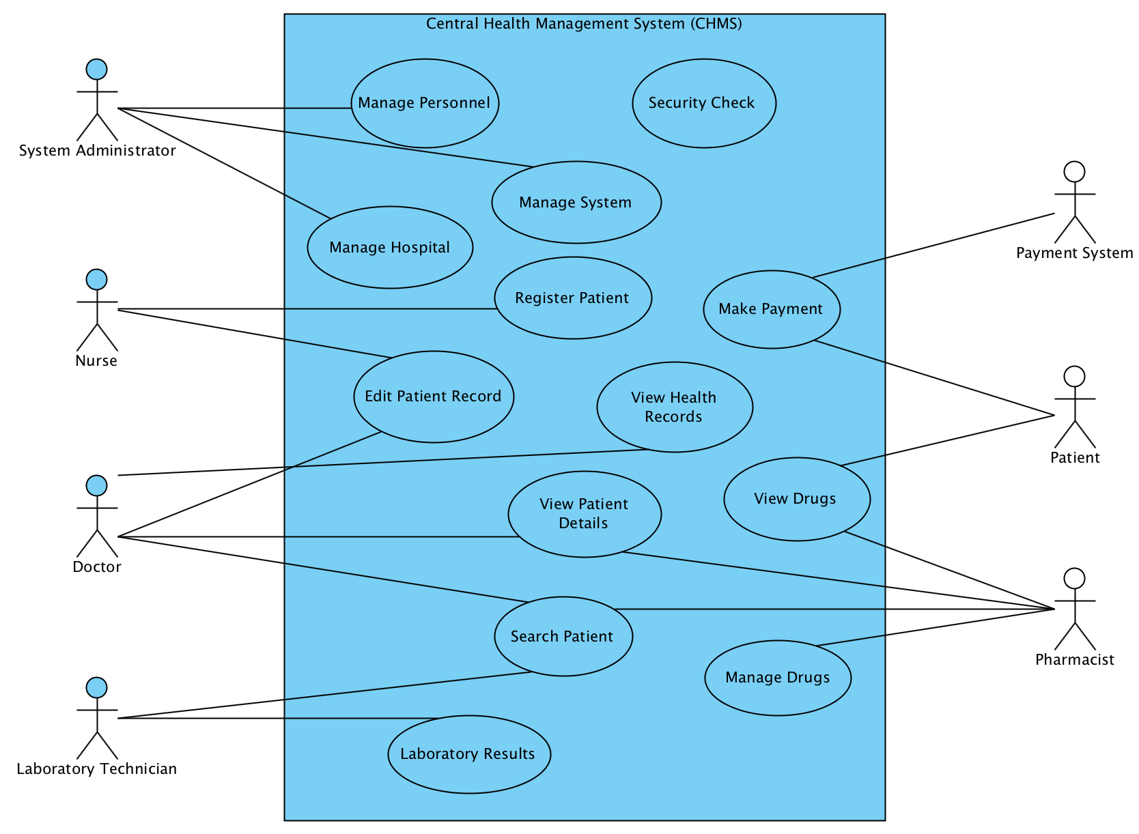

Figure 2.3.2.1 – System Use Case Diagram

System Users

* Security Check

All the system users must pass through a security check before they can get access to the system to perform their tasks. The security check involves a login page where users will be required to provide system username and password to be allowed access to the system.

System Administrator

* Manage Personnel, System and Hospitals

The role of the system administrator is to manage other users of the system. These users are the health officials that use the system to perform their tasks. The management of personnel involves adding new users, editing their profile, granting and denying users access to the system.

The administrator is also responsible for managing the system. This will be done by adding users to different roles and each role has its own rights and privileges on the system.

The management of hospitals and pharmacies is also another task for the system administrator. The admin can add, edit and disable new hospital and pharmacy on the system.

You should have an activity diagram based on scenario

I recommend that you combine chapter 3 and 2

# Chapter 3: Architecture And Design

This chapter will focus on the abstract models of the system. In doing so, Unified Modeling Language (UML) will be used to represent the system at different perspectives. UML will be used to describe the interaction and structural models to illustrate how the components of the system communicates with one another.

## 3.1 System Architecture

Central~HealthMS is a web application that should be accessed by all the users at any given time. The system however follows the generic client-server architecture to be able to allow all the users to access the application.

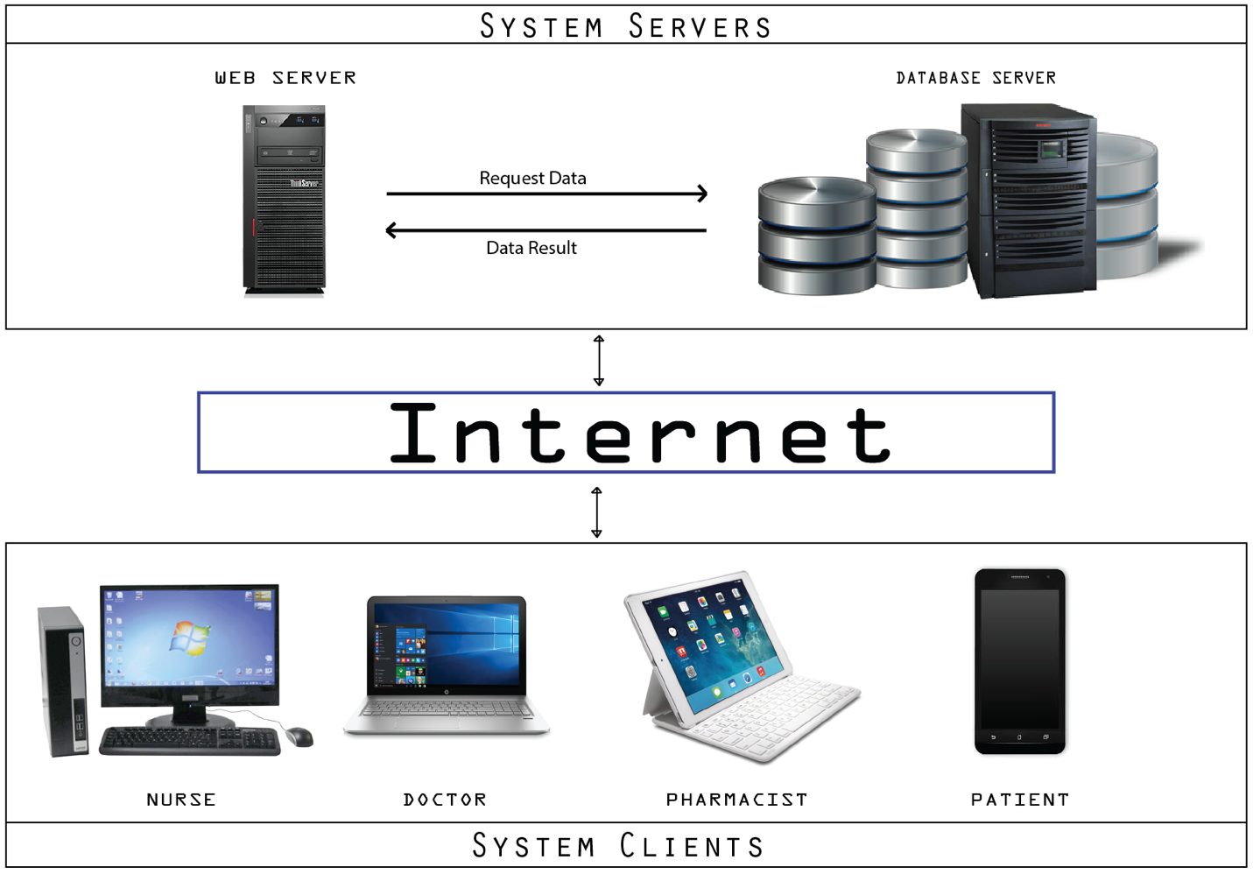

**Figure 3.1.1 Client-Server Architecture**

For a client to access the application, there must be a stable internet connection to be able to make an HTTP request to the server hosting Central~HealthMS application. When the client request for a page from the server, the client waits until it receives a reply in the form of content requested for from the server. This architecture is preferred because users can then access the application no matter their location all they need is access to the internet.

## 3.2 Architectural Pattern

The Central~HealthMS will be developed based on the the Model-View-Controller pattern. The structure of the system is based on three components that interact with each other. The model structure is a representation of the database. The model consists of the database architecture that the user interacts with indirectly. The model encompasses the data entities involved with the system. The views represent the interface which serves as an interpreter for the data in the model for the users of the system. The controller component serves as a channel connecting the model and the views. The controller updates the users view when there are changes in the model and updates the model when the user send a command.

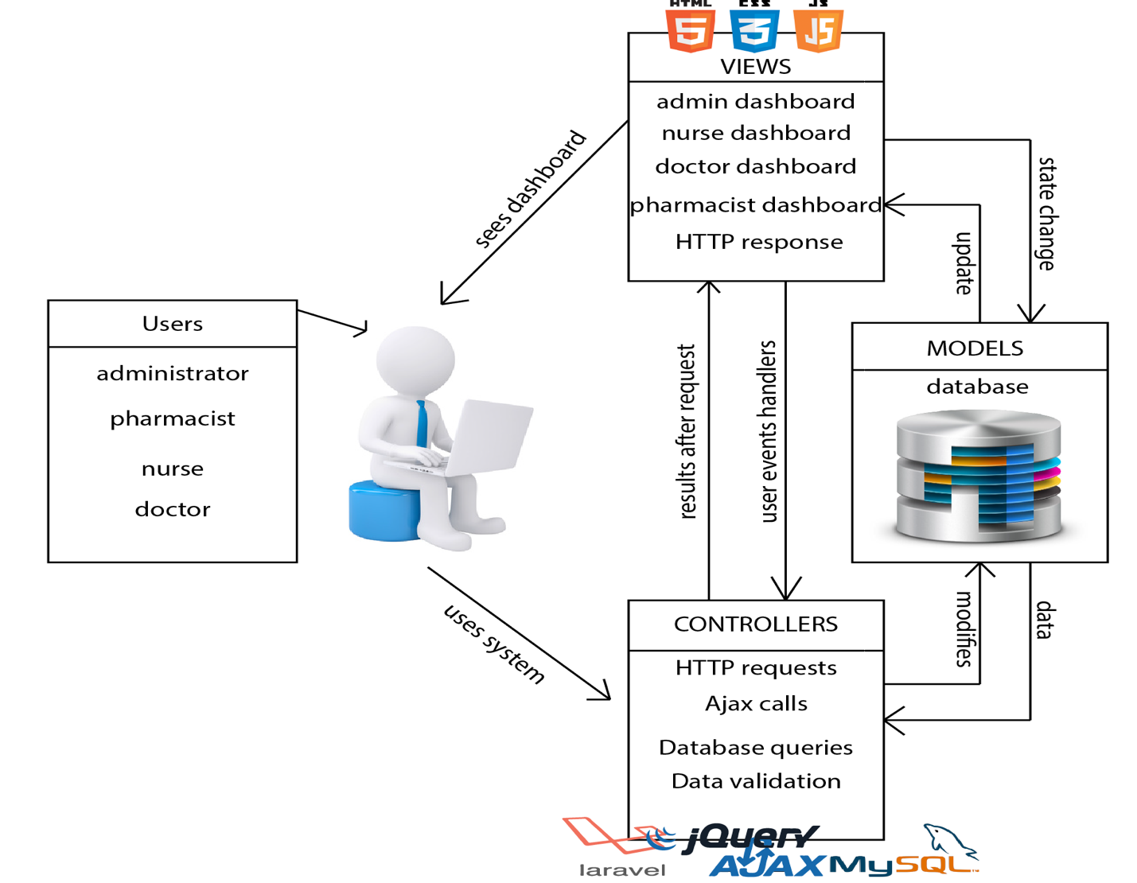

**Figure 3.2.1 – System Architecture**

The reason why MVC was chosen as the architectural design pattern for the Central~HealthMS system was due to its numerous advantages over other pattern. The pattern will help to represent the data in the model in multiple ways. Central~HealthMS system is a complicated system hence MVC will make updating the system easy. This is because when changes are made to the data entities in the model, these changes do not have any effect on how the views are displayed to the system users. This makes the components in the Central~HealthMS system independent on each other. The use of this pattern for the design of the software is also due to scalability of the system. Since it is advisable for future updates and addition of new functionalities at minimum cost. Since Central~HealthMS system consists of various components, the design pattern will help in faster development and also dividing the components into smaller modules to work on. This will make each component in the system to be easily debugged.

# Chapter 4: Implementation

This chapter focuses on the tools, components and libraries used for the implementation of Central~HealthMS. The chapter also provides screenshots of the various user interfaces of the system in different states.

## 4.1 Process Model

Before implementation of the software, it was necessary to know the user requirement and the design of the system. The waterfall software process model made it possible to be able to design the system before implementation. By following this model, the requirement of the system users was gathered and validated to know the implementable ones from the others. This was a major step towards the implementation of Central~HealthMS. After both functional and non-functional requirement of the target users were developed the system was then designed to suit the requirement.

## 4.2 Tools and Technology

This section elaborates the tools, languages and libraries that were used during the implementation of the Central~HealthMS.

|  |  |
| --- | --- |
| Tools | Description |
| PHP 7.0.4 | Hypertext Pre-processor (PHP) is a server-side scripting language. Since Central~HealthMS will be hosted on the server PHP makes it possible for clients to communicate with the application over the internet. In communicating with the server, MySQLi was used which is a more secured. |
| MySQL | MySQL is a relational database server that was used to model the database of the system. |
| HTML5 | For the client to be able to use the application, HyperText MarkUp Language (HTML5) was used to design the Graphical User Interface for the system so that users of the systems will be able to use the system with ease. |
| CSS3 | Cascading Style Sheets (CSS3) was used to design the user interfaces for the application. It was used to manipulate the HTML5 to produce better looking Graphical User Interface. |
| JavaScript | JavaScript was used for animations and transitions in the application. |
| Twig 1.24 | This is a PHP library template engine that was used with HTML5 to provide flexible templates for the application. |
| Android | This is the Operating System and language that the mobile version of the system was built with. It makes it possible to run the application on all android devices. |
| PhpStorm | This is the IDE that was used to develop the application. This IDE was used because it makes development easy and fast. |
| GitHub | This is a versioning control repository where the project was stored and used to track development progress during implementation. |

## 4.3 Platform

This section of the chapter highlights the platform that Central~HealthMS will be able to operate in without challenges. The constraints of the application on various platforms are also discussed for the users to have an idea of the applications operating platforms.

### 4.3.1 Web Version

The web version of the application can be accessed by users through Google Chrome, Safari and Mozilla Firefox browsers. The browsers that the application run on are not operating system specific. Hence, the application will run on all browsers on commonly used operating systems including Linux, Windows and Mac OS. There are also few constraints for the web application. It is not advisable to run it on Windows Internet Explorer because it has not been tested for that particular browser. Hence when run using internet explorer, it will not give the user the best of performance needed.

### 4.3.2 Mobile Version

The mobile version of the application will run on native Android Operating System. Hence any smart phone running the Android OS 4.1 and above will be able to install the application and use with ease. The only thing needed after installation of the application is to provide login details and after that all required access will be granted. There is also constraint on the mobile version of the application as there is for the web. The application however does not support android versions below Android 4.1 Jelly Bean. Hence users using any version of android below Jelly Bean will not be able to install the application.

## 4.4 Web Interface

This section of the chapter illustrates the numerous user interfaces for the application. A detailed description of each interface is provided.

* **Login Interface:** This is the first page that is used for security clearance for the application. When a user accesses the application, the user is provided with the login page in order to provide the necessary authentication details to be allowed access.

**Figure 4.4.1 Login Interface**

* **Dashboard Interface:** This is the landing page for the user after login is successful. Statistics of the drugs and patients in the system database are displayed for the user to easily make meaning of them. It also has the time of the day displayed on the header of the page. Statistics such as the number of patients that have been served and the total amount of money earned.

**Figure 4.4.2 Dashboard Interface**

4.5 Mobile Interface

Below is the user interface available for the mobile version of the application. The mobile version is mostly for the patients only.

* **Login Page:**

# Chapter 5: Testing and Results

# Chapter 6: Conclusion

# Chapter 7: Conclusion and Recommendation

# Bibliography

Nyonmorworko, N. D. (2015, April 15). *Reflections in the mirror; Records keeping in Ghana's Health Sector*. Retrieved October 22, 2015, from graphic.com.gh: http://graphic.com.gh/features/opinion/41676-reflections-in-the-mirror-records-keeping-in-ghana-s-health-sector.html

Ohene-Bonsu, K. G. (2015). *Centralized Hospital Management System For Health Centers In Ghana.* Ashesi University College, Computer Science, Berekuso.

Poikonen, J. (2009, March 16). *50 Successful Open Source Projects That Are Changing Medicine*. Retrieved October 22, 2015, from pharmacyinformatics.blogspot.com: http://pharmacyinformatics.blogspot.com/2009/03/50-successful-open-source-projects-that.html

Sommerville, I. (2011). *Software Engineering* (9th Edition ed.). United States of America: Addison-Wesley.